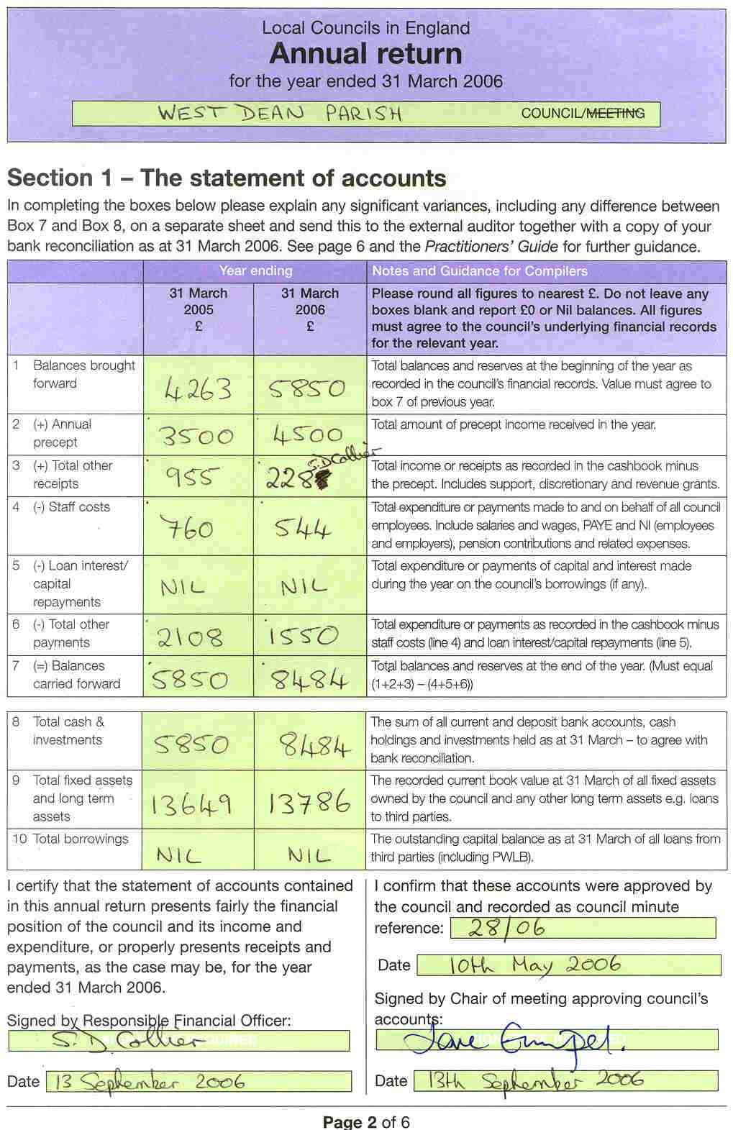 | 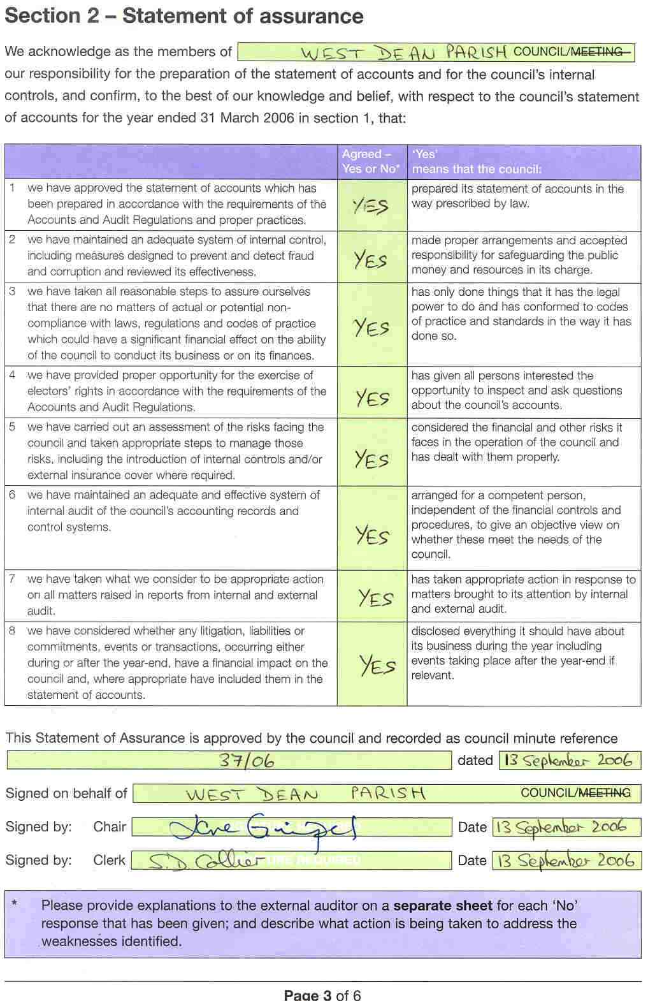 | 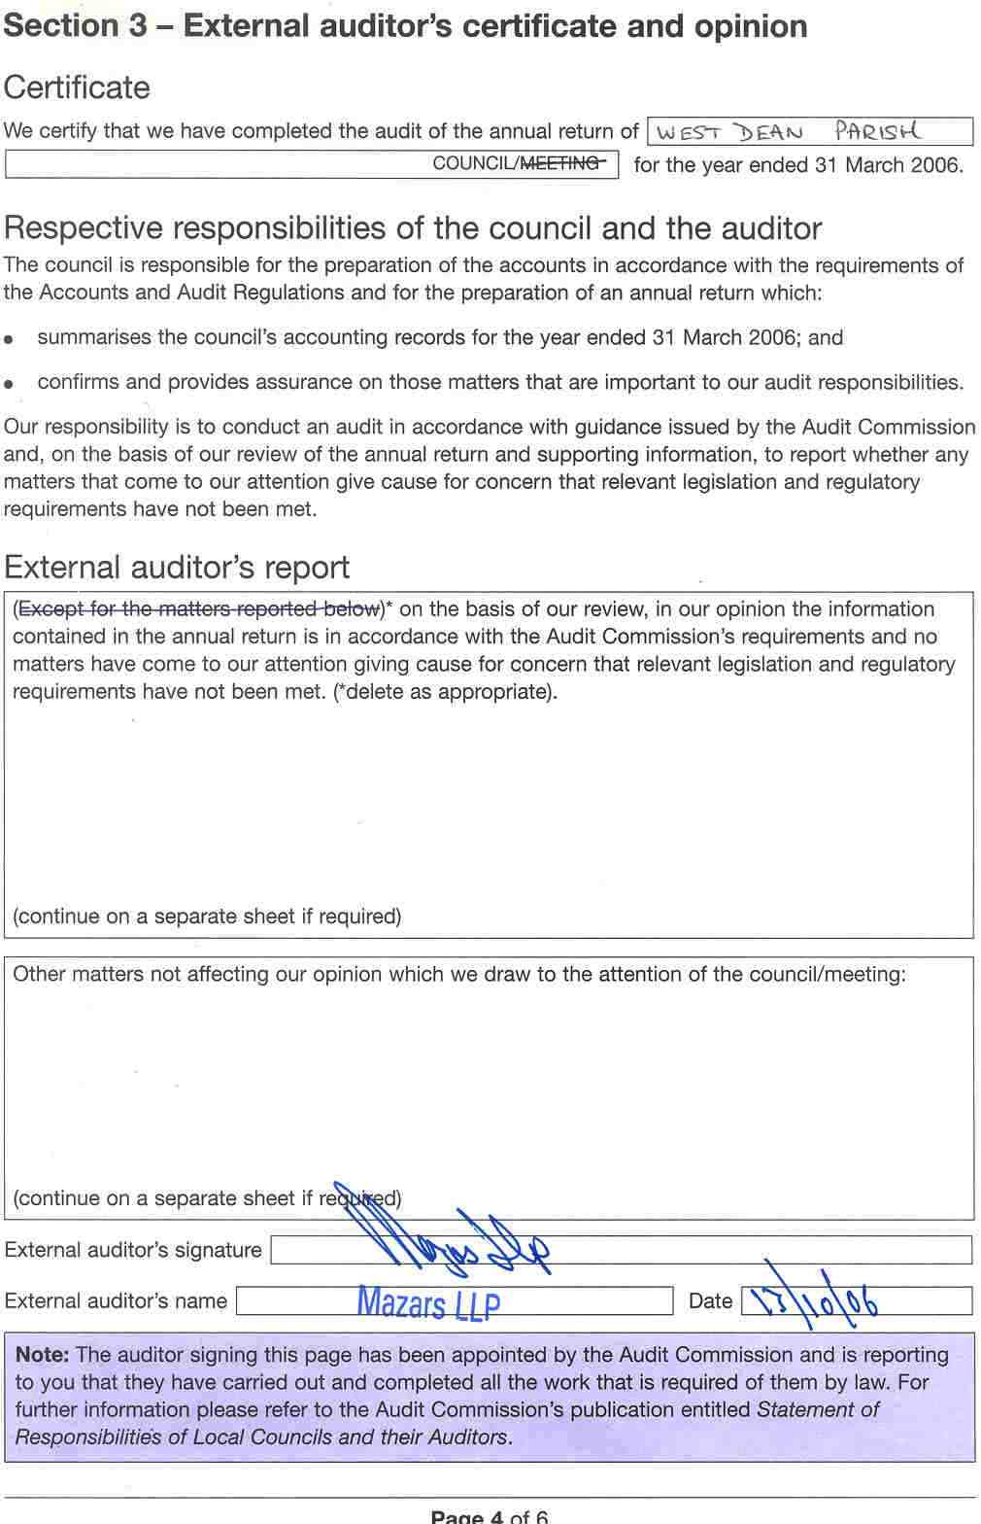
This is a certified reproduction of the 2006 Annual Return for West Dean Parish Council, published as required by he Audit Commission Act 1998 and The Accounts and Audit Regulations 2003 (SI 2003/533).
A full sized copy may be obtained by sending a stamped self-addressed A4 envelope to:
The Parish Clerk, West Dean Parish Council, Tanglewood, West Dean, Salisbury SP5 1JJ
This notice will be displayed for a minimum of 14 days commencing 23 November 2006.
Sally Collier
Parish Clerk
23 November 2006

